D07 - Deactivate additional CPE

Version Control:

Use Case Name: |  | D07 - Deactivate additional CPE
Use Case Owner: |  | Prashant Marathe
Current Version |  | 0.1
Use Case Version History
Modified Date | Version |  | Modified By | Change Description
November 18, 2009 | 0.1 |  | Prashant Marathe | Initial Version

Brief Description:
This use case describes the process by which a YouSee subscriber orders an deactivation on the additional CPE service with a dynamic IP Address. The use case is written from the perspective of the SMP provisioning solution.

Yousee only offers the Static Ip services on Standard CPE.

Related Documents
- YouSee SMP SOW2Architecture Requirements Document
- YouSee SMP SOW2 Business Requirements Document
- Cisco BACC TC Specification

Related Use Cases

Pre-Conditions
- Subscriber is an active broadband subscriber with an additional CPE device

Post-Conditions
- Subscribers additional CPE device is deactivated.

Use Case

Primary Flow Diagram
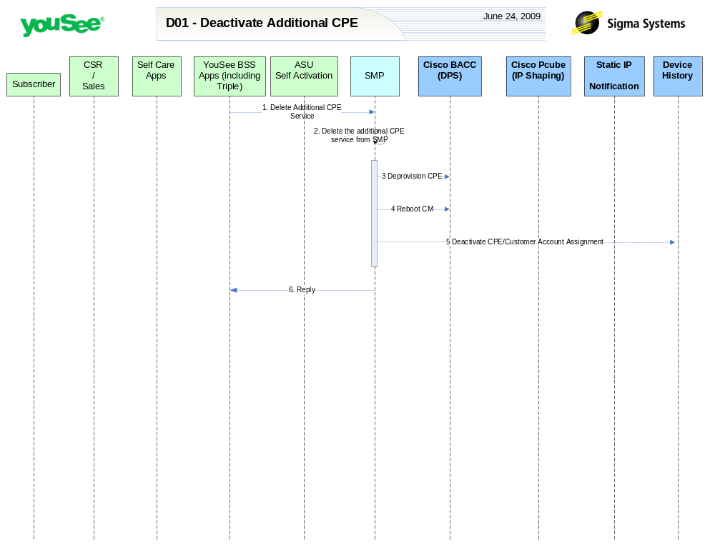

Primary Flow Detail
# | Actor: Key Action | Description | Alternate Flows/Details
 | YouSee BSS: Order is communicated to SMP for deactivation of Additional CPE | YouSee BSS (Triple) will communicate the order to SMP through SMP’s OSS/J Order Management API. SMP will be required to translate these service/service attributes to engineering level resources and resource attributes.
 | SMP: Remove Additional CPE Service | SMP will remove the additional CPE service under the Broadband Cable Service plan.
 | SMP: Removes the CPE from BACC | For the CPE MAC address supplied from ASU, SMP will remove the MAC address as a ‘Computer’ object in BACC.
 | SMP: requests BACC to reboot the CM Device | Device is rebooted resulting in it receiving the new configuration.  This needs to occur prior to the CM deletion from BACC as BACC cannot reset a deleted device. This introduces a minor timing issue, but for the vast majority the device is deleted from BACC before it completes the reboot cycle.
 | SMP: deletes CPE from Device History | SMP will mark the CPE in the device history table as deactivated
 | SMP: Replies back to Triple the status of Deactivation | SMP will reply the status of Deprovisioning Order to Triple.

